CHIEF MASTER SERGEANT JARROD A. TISTHAMMER
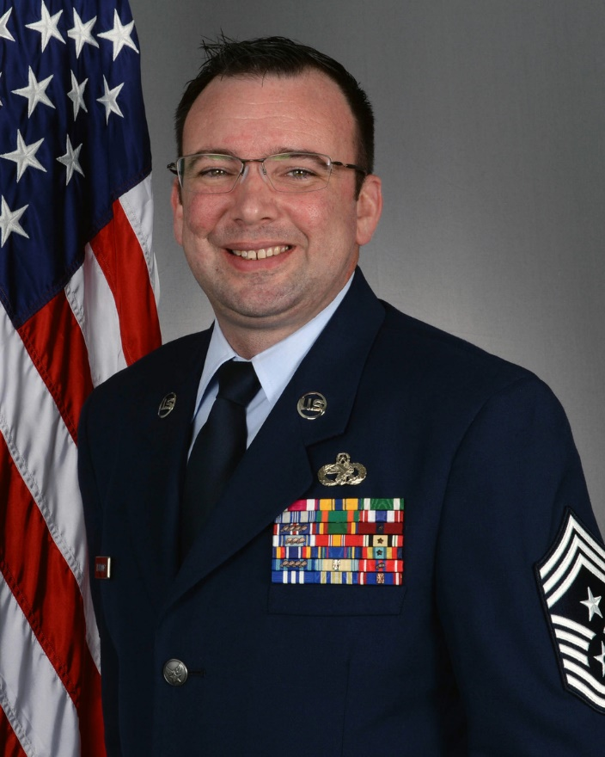
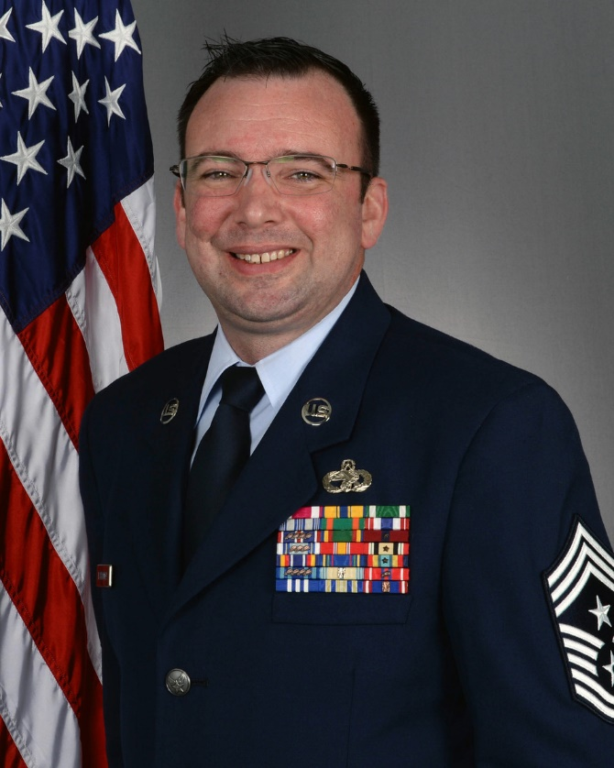
Chief Master Sgt. Jarrod A. Tisthammer is the Command Chief Master Sergeant of the 155th Air Refueling Wing in Lincoln, Nebraska. In this role, he is the principal advisor to the commander and senior staff on all matters affecting the enlisted force. He oversees the mentorship, health, welfare, and discipline of more than 800 Airmen assigned to the Wing. Chief Tisthammer is charged with the professional development and proper utilization of the enlisted force, ensuring the unit is trained and equipped to accomplish their federal, state, and local missions.

CMSgt. Tisthammer began his military career in 1999 with the U.S. Marine Corps after graduating from Laurel-Concord High School. Following recruit training in San Diego, California, he served as a motor vehicle operator in Kaneohe Bay, Hawaii. Transitioning to the intelligence field in 2004, he supported Operation IRAQI FREEDOM, serving as an Intelligence Analyst at Camp Fallujah and Camp Habbaniyah, Iraq.

In 2010, Chief Tisthammer joined the U.S. Air Force, specializing in Air Transportation. He focused on building high-performing teams capable of handling diverse and complex missions. Prior to his current assignment, the Chief served as the Senior Enlisted Leader for the 155th Logistics Readiness Squadron.

EDUCATION
2000 Motor Vehicle Operator Course, Fort Leonard Wood, Mo.
2004 Corporal’s Leadership Course, Marine Corps Base Hawaii, Kaneohe Bay, Hawaii.
2004 Intelligence Analyst Course, Navy and Marine Corps Intelligence Center, Dam Neck, Va.
2010 Air Transportation Apprentice Course, 345th Training Squadron, San Antonio, Texas
2011 Noncommissioned Officer Academy, McGhee Tyson ANGB, Tenn.
2012 Hazardous Materials for Airlift Inspector, Fort Gregg-Adams, Va.
2012 Associate of Applied Science Degree, Transportation Management, Community College of the Air Force
2014 Senior Noncommissioned Officer Academy, 155th Air Refueling Wing, Lincoln Neb., by correspondence
2014 Bachelor of Science, Criminology and Criminal Justice, University of Nebraska, Omaha, Neb.
2014 Airlift Load Planners Course, Transportation Proficiency Center, Dobbins Air Force Base, Ga.
2015 Joint Inspection for Airlift Course, Air Dominance Center, Savannah, Ga.
2016 Nebraska National Guard Leadership Enrichment and Development Course, Camp Ashland, Neb.
2021 Senior Enlisted Joint PME I & II, 155th Air Refueling Wing, Lincoln Neb., by correspondence
2023 Chief Master Sergeant Orientation Course, Joint Base Andrews, Md.

ASSIGNMENTS
- November 1999–February 2000, Marine Corps Recruit Training, San Diego, Calif.
- March 2000–April 2000, Marine Combat Training, Camp Pendleton, Oceanside, Calif.
- April 2000–May 2000, Motor Vehicle Operator School, Fort Leonard Wood, Mo.
- May 2000–August 2004, Motor Vehicle Operator, Combat Service Support Group Three, Kaneohe Bay, Hawaii
Assignments cont.
- September 2004–December 2004, Navy and Marine Corps Intelligence Center, Dam Neck, Va.
- January 2005–May 2006, Intelligence Analyst, 2nd Battalion, 2nd Marine Division, Camp Lejeune, N.C.
- June 2006–March 2008, Intelligence Chief, 3rd Battalion, 2nd Marine Division, Camp Lejeune, N.C.
- January 2010–April 2010, Air Transportation Apprentice Course, 345th Training Squadron, San Antonio, Texas
- May 2010–October 2013, Air Transportation Craftsman, 155th Air Refueling Wing, Lincoln ANGB, Lincoln, Neb.
- October 2013–October 2017, Air Transportation Superintendent, 155th Air Refueling Wing, Lincoln ANGB, Neb.
- November 2017–January 2025, Air Transportation Manager, 155th Air Refueling Wing, Lincoln ANGB, Neb.
- June 2021–January 2025, Senior Enlisted Leader, 155th Air Refueling Wing, Lincoln ANGB, Neb.
- January 2025–present, Command Chief Master Sergeant, 155th Air Refueling Wing, Lincoln, ANGB, Neb.

MAJOR AWARDS AND DECORATIONS
Meritorious Service Medal
Air and Space Commendation Medal
Navy Commendation Medal
Air and Space Achievement Medal
Navy and Marine Corps Achievement Medal
Marine Corps Good Conduct Medal with one bronze star

STATE AWARDS AND DECORATIONS
Nebraska Commendation Medal
Nebraska Emergency Service Ribbon

PROFESSIONAL MEMBERSHIPS AND ASSOCIATIONS
Alpha Lamda Sigma, Honor Society, University of Nebraska at Omaha, 2014
Enlisted Association of the National Guard of Nebraska, Lifetime Member, 2012-Pres.
Nebraska Air National Guard Civic Association, President, 2020-Pres.

EFFECTIVE DATES OF PROMOTION
Private First Class May 1, 2000
Lance Corporal Feb 1, 2001
Corporal Sept 1, 2002
Sergeant Feb 1, 2004
Staff Sergeant (USMC) May 1, 2007
Technical Sergeant March 4, 2009
Master Sergeant Aug 8, 2012
Senior Master Sergeant Oct 15, 2017
Chief Master Sergeant Nov 14, 2022

(Current as of Jan 2025)

